Assignment 5: Implement Minimax Algorithm for Game Playing

Problem Statement
The goal of this assignment is to implement the Minimax algorithm to create an AI for a two-player game, such as Tic-Tac-Toe. The AI should evaluate potential moves and select the optimal one using game-theoretic reasoning.

Objectives
- Understand the principles of the Minimax algorithm.
- Implement the Minimax algorithm to enable strategic gameplay for AI.

Theory
What is the Minimax Algorithm?
The Minimax algorithm is a recursive decision-making strategy used in turn-based, two-player games. It aims to minimize the possible loss for a worst-case scenario. When both players play optimally, it maximizes the minimum gain for the AI player while minimizing the opponent's maximum gain.

Methodology
- Generate a Game Tree:
  - Construct a game tree where each node represents a possible game state.
  - Edges represent legal moves.
  - The root node corresponds to the current game state.
- Evaluate Terminal Nodes:
  - Terminal nodes represent game-end states (win, loss, or draw).
  - Assign scores based on the outcome:
    - AI win: +1
    - Opponent win: -1
    - Draw: 0
- Backpropagate Scores:
  - Propagate scores from terminal nodes upward.
  - At each level, the AI selects the move that maximizes its score while minimizing the opponent's score.

Working Principle / Algorithm
- Define the Game State:
  - Represent the board and current player.
- Generate Possible Moves:
  - Identify all legal moves for the current player.
- Recursively Evaluate Moves:
  - For each move:
    - Apply the move and switch the player.
    - If the game ends, return the score.
    - Otherwise, recursively call the Minimax function to evaluate the opponent’s best response.
    - Undo the move to restore the previous game state.
- Choose the Optimal Move:
  - Select the move with the highest score for the AI player after evaluating all options.

Advantages
- Optimal Strategy: Guarantees the best move for AI if both players play optimally.
- Simple Implementation: Easy to implement for small game trees like Tic-Tac-Toe.

Disadvantages / Limitations
- Computationally Intensive: Number of game states grows exponentially with larger boards or more complex games.
- Memory Usage: Storing the full game tree may require significant memory for larger games.

Problem Statement
The goal of this assignment is to implement the Minimax algorithm to create an AI for a two-player game, such as Tic-Tac-Toe. The AI should evaluate potential moves and select the optimal one using game-theoretic reasoning.

Objectives
- Understand the principles of the Minimax algorithm.
- Implement the Minimax algorithm to enable strategic gameplay for AI.

Theory
What is the Minimax Algorithm?
The Minimax algorithm is a recursive decision-making strategy used in turn-based, two-player games. It aims to minimize the possible loss for a worst-case scenario. When both players play optimally, it maximizes the minimum gain for the AI player while minimizing the opponent's maximum gain.

Methodology
- Generate a Game Tree:
  - Construct a game tree where each node represents a possible game state.
  - Edges represent legal moves.
  - The root node corresponds to the current game state.
- Evaluate Terminal Nodes:
  - Terminal nodes represent game-end states (win, loss, or draw).
  - Assign scores based on the outcome:
    - AI win: +1
    - Opponent win: -1
    - Draw: 0
- Backpropagate Scores:
  - Propagate scores from terminal nodes upward.
  - At each level, the AI selects the move that maximizes its score while minimizing the opponent's score.

Working Principle / Algorithm
- Define the Game State:
  - Represent the board and current player.
- Generate Possible Moves:
  - Identify all legal moves for the current player.
- Recursively Evaluate Moves:
  - For each move:
    - Apply the move and switch the player.
    - If the game ends, return the score.
    - Otherwise, recursively call the Minimax function to evaluate the opponent’s best response.
    - Undo the move to restore the previous game state.
- Choose the Optimal Move:
  - Select the move with the highest score for the AI player after evaluating all options.

Advantages
- Optimal Strategy: Guarantees the best move for AI if both players play optimally.
- Simple Implementation: Easy to implement for small game trees like Tic-Tac-Toe.

Disadvantages / Limitations
- Computationally Intensive: Number of game states grows exponentially with larger boards or more complex games.
- Memory Usage: Storing the full game tree may require significant memory for larger games.
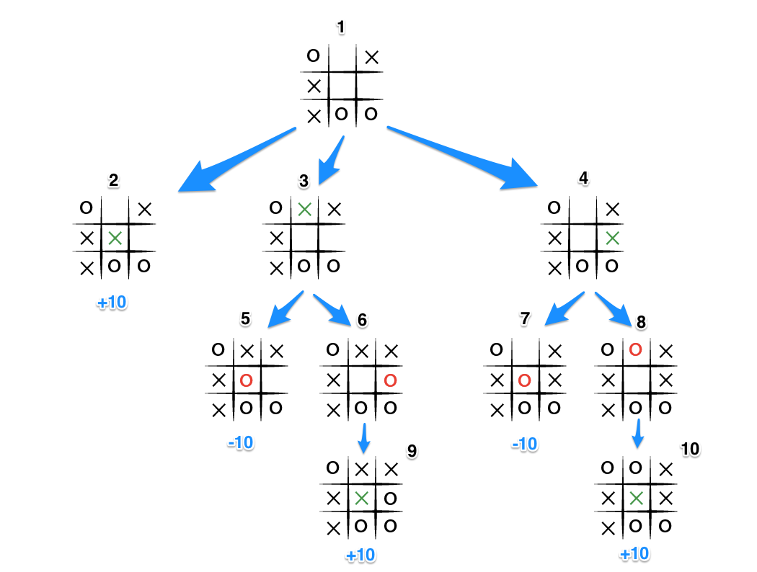

Diagram

Conclusion
The Minimax algorithm provides a solid foundation for game-playing AI, ensuring optimal moves in strategic games. By systematically evaluating potential moves, the algorithm allows for the creation of intelligent opponents in two-player games.
Code:-
// Source code is decompiled from a .class file using FernFlower decompiler (from Intellij IDEA).
import java.util.Scanner;

public class TicTacToeMinimax {
static final char PLAYER = 'X';
static final char HUMAN = 'O';

public TicTacToeMinimax() {
}

static void printBoard(char[][] var0) {
System.out.println("Board:");

for(int var1 = 0; var1 < 3; ++var1) {
for(int var2 = 0; var2 < 3; ++var2) {
System.out.print(var0[var1][var2] + " ");
}

System.out.println();
}

}

static int evaluate(char[][] var0) {
for(int var1 = 0; var1 < 3; ++var1) {
if (var0[var1][0] == var0[var1][1] && var0[var1][1] == var0[var1][2]) {
if (var0[var1][0] == 'X') {
return 10;
}

if (var0[var1][0] == 'O') {
return -10;
}
}

if (var0[0][var1] == var0[1][var1] && var0[1][var1] == var0[2][var1]) {
if (var0[0][var1] == 'X') {
return 10;
}

if (var0[0][var1] == 'O') {
return -10;
}
}
}

if (var0[0][0] == var0[1][1] && var0[1][1] == var0[2][2]) {
if (var0[0][0] == 'X') {
return 10;
}

if (var0[0][0] == 'O') {
return -10;
}
}

if (var0[0][2] == var0[1][1] && var0[1][1] == var0[2][0]) {
if (var0[0][2] == 'X') {
return 10;
}

if (var0[0][2] == 'O') {
return -10;
}
}

return 0;
}

static boolean isMovesLeft(char[][] var0) {
for(int var1 = 0; var1 < 3; ++var1) {
for(int var2 = 0; var2 < 3; ++var2) {
if (var0[var1][var2] == '_') {
return true;
}
}
}

return false;
}

static int minimax(char[][] var0, int var1, boolean var2) {
int var3 = evaluate(var0);
if (var3 == 10) {
return var3 - var1;
} else if (var3 == -10) {
return var3 + var1;
} else if (!isMovesLeft(var0)) {
return 0;
} else {
int var4;
int var5;
int var6;
if (var2) {
var4 = Integer.MIN_VALUE;

for(var5 = 0; var5 < 3; ++var5) {
for(var6 = 0; var6 < 3; ++var6) {
if (var0[var5][var6] == '_') {
var0[var5][var6] = 'X';
var4 = Math.max(var4, minimax(var0, var1 + 1, false));
var0[var5][var6] = '_';
}
}
}

return var4;
} else {
var4 = Integer.MAX_VALUE;

for(var5 = 0; var5 < 3; ++var5) {
for(var6 = 0; var6 < 3; ++var6) {
if (var0[var5][var6] == '_') {
var0[var5][var6] = 'O';
var4 = Math.min(var4, minimax(var0, var1 + 1, true));
var0[var5][var6] = '_';
}
}
}

return var4;
}
}
}

static int[] findBestMove(char[][] var0) {
int var1 = Integer.MIN_VALUE;
int[] var2 = new int[]{-1, -1};

for(int var3 = 0; var3 < 3; ++var3) {
for(int var4 = 0; var4 < 3; ++var4) {
if (var0[var3][var4] == '_') {
var0[var3][var4] = 'X';
int var5 = minimax(var0, 0, false);
var0[var3][var4] = '_';
if (var5 > var1) {
var2[0] = var3;
var2[1] = var4;
var1 = var5;
}
}
}
}

return var2;
}

public static void main(String[] var0) {
Scanner var1 = new Scanner(System.in);
char[][] var2 = new char[][]{{'_', '_', '_'}, {'_', '_', '_'}, {'_', '_', '_'}};
System.out.println("Tic-Tac-Toe Game!");
printBoard(var2);

label31:
while(true) {
while(true) {
System.out.print("Enter your move (row and column: 0-2): ");
int var3 = var1.nextInt();
int var4 = var1.nextInt();
if (var2[var3][var4] == '_') {
var2[var3][var4] = 'O';
printBoard(var2);
if (evaluate(var2) == -10) {
System.out.println("You win!");
break label31;
}

if (!isMovesLeft(var2)) {
System.out.println("Draw!");
break label31;
}

int[] var5 = findBestMove(var2);
var2[var5[0]][var5[1]] = 'X';
System.out.println("AI plays:");
printBoard(var2);
if (evaluate(var2) == 10) {
System.out.println("AI wins!");
break label31;
}

if (!isMovesLeft(var2)) {
System.out.println("Draw!");
break label31;
}
} else {
System.out.println("Invalid move! Try again.");
}
}
}

var1.close();
}
}

Output :-
Tic-Tac-Toe Game!
Board:
_ _ _
_ _ _
_ _ _

Enter your move (row and column: 0-2): 0 0
Board:
O _ _
_ _ _
_ _ _

AI plays:
Board:
O _ _
_ X _
_ _ _

Enter your move (row and column: 0-2): 1 0
Board:
O _ _
O X _
_ _ _

AI plays:
Board:
O _ _
O X X
_ _ _
Enter your move (row and column: 0-2): 2 0
Board:
O _ _
O X X
O _ _
You win!

